Nama : Muhammad Audy

NRP : 1152000041

PBO TUGAS 2

Coding :

*#Nama : Muhammad Audy*

*#NRP : 1152000041*

*#Tugas 2*

**import** random

**import** os

class Hero:

**def** __init__(*self*, **n**, **ba**, **hp**, **skill**, **pasif**):

*self*.nama **=** n

*self*.basicAttack **=** int(ba)

*self*.hp **=** int(hp)

*self*.skill **=** skill

*self*.pasif **=** pasif

*self*.item **=** []

**def** tambahItem(*self*, **item**):

*self*.item.append(item)

class Magical(*Hero*):

**def** __init__(*self*, **n**, **ba**, **hp**, **skill**, **mp**, **pd**, **pasif**):

*self*.magicPower **=** int(mp)

*self*.physicalDefense **=** int(pd)

        super().__init__(n, ba, hp, skill, pasif)

class Physical(*Hero*):

**def** __init__(*self*, **n**, **ba**, **hp**, **skill**, **pa**, **md**, **pasif**):

*self*.physicalAttack **=** int(pa)

*self*.magicDefense **=** int(md)

        super().__init__(n, ba, hp, skill, pasif)

class Item:

**def** __init__(*self*, **n**, **dmg**):

*self*.nama **=** n

*self*.damage **=** int(dmg)

class Skill:

**def** __init__(*self*, **n**, **attck**, **deff**):

*self*.nama **=** n

*self*.attack **=** int(attck)

*self*.defense **=** int(deff)

save_item_dari_input_masukan **=** []

mystic_gush **=** Skill("Mystic Gush", 10, 80)

deadly_magic **=** Skill("Deadly Magic", 20, 70)

order_n_chaos **=** Skill("Order & Chaos", 30, 60)

violet_reqiem **=** Skill("Violet Reqiem", 40, 50)

zaman_force **=** Skill("Zaman Force", 40, 50)

vegeane_flame **=** Skill("Vegeane Flame", 60, 30)

feathered_air_strike **=** Skill("Fearhered Air Strike", 70, 20)

bast_feast **=** Skill("Bats Feast", 80, 10)

triple_sweep **=** Skill("Triple Sweep", 20, 10)

alecto **=** Skill("Alecto : Final Blow", 30, 15)

the_way_of_dragon **=** Skill("The Way of Dragon", 40, 20)

pasif **=** Skill("Pasif", 200, 0)

gord **=** Magical("Gord", 100, 800, mystic_gush, 100, 100, 0)

harley **=** Magical("Harley", 100, 700, deadly_magic, 200, 200, 0)

lunox **=** Magical("Lunox", 100, 600, order_n_chaos, 300, 300, pasif)

guinevere **=** Magical("Guinevere", 100, 500, violet_reqiem, 400, 400, 0)

harith **=** Magical("Harith", 100, 400, zaman_force, 500, 500, 0)

valir **=** Magical("Valir", 100, 300, vegeane_flame, 600, 600, 0)

pharsa **=** Magical("Pharsa", 100, 200, feathered_air_strike, 700, 700, pasif)

cecillion **=** Magical("Cecillion", 100, 100, bast_feast, 800, 800, 0)

list_hero_magic **=** [gord, harley, lunox, guinevere, harith, valir, pharsa, cecillion]

saber **=** Physical("Saber", 100, 400, triple_sweep, 400, 400, pasif)

benedetta **=** Physical("Benedetta", 100, 300, alecto, 500, 500, pasif)

chou **=** Physical("Chou", 100, 500, the_way_of_dragon, 40, 20, pasif)

hero_random_magic1 **=** (random.choice(list_hero_magic))

hero_random_magic2 **=** (random.choice(list_hero_magic))

hero_random_magic3 **=** (random.choice(list_hero_magic))

save_hero_magic_random1 **=** hero_random_magic1

save_hero_magic_random2 **=** hero_random_magic2

save_hero_magic_random3 **=** hero_random_magic3

**while**(True):

    print("selamat datang di pertempuran 3 vs 3")

    print("pilihan :")

    print("1. lihat daftar hero magic")

    print("2. lihat daftar hero pyhical")

    print("3. lihat skill hero magic")

    print("4. lihat skill hero physical")

    print("5. pilih hero & buat item")

    print("6. beli item")

    print("7. battle")

    print("8. keluar")

    print("pilih menu: ")

    pilih_menu **=** int(input())

**if** pilih_menu **==** 1:

        print("#########")

        print("Daftar nama hero magic")

        print("$$$$$$$$$")

        print("gord")

        print("harley")

        print("lunox")

        print("guinevere")

        print("harith")

        print("valir")

        print("pharsa")

        print("cecillion")

        print("#########")

        os.system("pause")

**elif** pilih_menu **==** 2:

        print("menu 2")

        print("#########")

        print("Daftar nama hero magic")

        print("$$$$$$$$$")

        print("saber")

        print("benedetta")

        print("chou")

        print("#########")

        os.system("pause")

**elif** pilih_menu **==** 3:

        print("#########")

        print("daftar nama skill hero magic")

        print("$$$$$$$$$")

        print("gord memiliki skill ", gord.skill.nama)

        print("harley memiliki skill ", harley.skill.nama)

        print("lunox memiliki skill order n chaos", gord.skill.nama)

        print("lunox memiliki skill pasif", lunox.pasif.nama)

        print("guinevere memiliki skill violet reqiem", guinevere.skill.nama)

        print("harith memiliki skill zaman force", harith.skill.nama)

        print("valir memiliki skill fegeane flame", valir.skill.nama)

        print("pharsa memiliki skill feathered air strike", pharsa.skill.nama)

        print("pharsa memiliki skill pasif", pharsa.pasif.nama)

        print("cecilion memiliki skill bast feast", cecillion.skill.nama)

        print("#########")

        os.system("pause")

**elif** pilih_menu **==** 4:

        print("#########")

        print("daftar nama skill hero physical")

        print("$$$$$$$$$")

        print("saber memiliki skill triple sweap", saber.skill.nama)

        print("saber memiliki skill pasif", saber.pasif.nama)

        print("benedetta memiliki skill alecto", benedetta.skill.nama)

        print("benedetta memiliki skill pasif", benedetta.pasif.nama)

        print("chou memiliki skill the way of the dragon", chou.skill.nama)

        print("chou memiliki skill pasif", chou.pasif.nama)

        print("#########")

        os.system("pause")

**elif** pilih_menu **==** 5:

        print("3 Magic VS 3 Physical")

        print(save_hero_magic_random1.nama)

        print("vs")

        print("saber")

        print("3 Magic VS 3 Physical")

        print(save_hero_magic_random2.nama)

        print("vs")

        print("benedetta")

        print("3 Magic VS 3 Physical")

        print(save_hero_magic_random3.nama)

        print("vs")

        print("chou")

        os.system('pause')

        print("buat item dan tambahkan kepada hero")

        print("membuat beberapa objek item sampai berhenti")

        i **=** 1

**while** True:

            print(f"Item ke- {i}")

            masukanItem **=** input("Masukan atribut item / berhenti : ")

**if** masukanItem **==** "berhenti":

**break**

**else**:

                listMasukan **=** masukanItem.split("#")

                save_item_dari_input_masukan.append(Item(listMasukan[0], listMasukan[1]))

                i **+=** 1

        os.system('pause')

**elif** pilih_menu **==** 6:

        random_item1 **=** (random.choice(save_item_dari_input_masukan))

        random_item2 **=** (random.choice(save_item_dari_input_masukan))

        random_item3 **=** (random.choice(save_item_dari_input_masukan))

        random_item4 **=** (random.choice(save_item_dari_input_masukan))

        random_item5 **=** (random.choice(save_item_dari_input_masukan))

        random_item6 **=** (random.choice(save_item_dari_input_masukan))

        save_random_item1 **=** random_item1

        save_random_item2 **=** random_item2

        save_random_item3 **=** random_item3

        save_random_item4 **=** random_item4

        save_random_item5 **=** random_item5

        save_random_item6 **=** random_item6

        print("hero membeli item")

        print(save_hero_magic_random1.nama, "membeli item", save_random_item1.nama)

        print(save_hero_magic_random2.nama, "membeli item", save_random_item2.nama)

        print(save_hero_magic_random3.nama, "membeli item", save_random_item3.nama)

        print("saber membeli item", save_random_item4.nama)

        print("benedetta membeli item", save_random_item5.nama)

        print("chou membeli item", save_random_item6.nama)

        save_hero_magic_random1.tambahItem(save_random_item1)

        save_hero_magic_random2.tambahItem(save_random_item2)

        save_hero_magic_random3.tambahItem(save_random_item3)

        saber.tambahItem(save_random_item4)

        benedetta.tambahItem(save_random_item5)

        chou.tambahItem(save_random_item6)

        os.system('pause')

**elif** pilih_menu **==** 7:

        total_serangan1_1 **=** save_hero_magic_random1.basicAttack **+** save_random_item1.damage

        saber.magicDefense **=** saber.magicDefense **-** total_serangan1_1

        total_serangan2_1 **=** saber.basicAttack **+** save_random_item4.damage

        save_hero_magic_random1.physicalDefense **=** save_hero_magic_random1.physicalDefense **-** total_serangan2_1

        print("Battle dimulai")

        print("#########################")

        print(save_hero_magic_random1.nama, "menyerang saber dengan basic attack + item ", save_random_item1.nama, "sebesar ", total_serangan1_1)

        print("magic defense saber menjadi ", saber.magicDefense)

        print("saber menyerang ", save_hero_magic_random1.nama, "dengan basic attack + item ", save_random_item4.nama, "sebesar ", total_serangan2_1)

        print("physical defense ", save_hero_magic_random1.nama, "menjadi ", save_hero_magic_random1.physicalDefense)

        total_serangan3_1 **=** save_hero_magic_random1.magicPower **+** save_hero_magic_random1.skill.attack

        saber.magicDefense **=** saber.magicDefense **-** total_serangan3_1

        print(save_hero_magic_random1.nama, "menyerang saber dengan magic attack + ultimate ", save_hero_magic_random1.skill.nama, "sebesar ", total_serangan3_1)

        print("magic defense saber menjadi", saber.magicDefense)

        total_serangan4_1 **=** saber.physicalAttack **+** saber.skill.attack **+** saber.pasif.attack

        save_hero_magic_random1.physicalDefense **=** save_hero_magic_random1.physicalDefense **-** total_serangan4_1

        print("saber menyerang ", save_hero_magic_random1.nama, "dengan physic attack + ultimate ", saber.skill.nama, "+ pasif sebesar", total_serangan4_1)

        print("physical defense ", save_hero_magic_random1.nama, "menjadi ", save_hero_magic_random1.physicalDefense)

**if** save_hero_magic_random1.hp **>** saber.hp:

            print("############################")

            print(save_hero_magic_random1.nama, " WIN" )

            print("############################")

**else**:

            print("############################")

            print("saber WIN" )

            print("############################")

        total_serangan1_2 **=** save_hero_magic_random2.basicAttack **+** save_random_item2.damage

        benedetta.magicDefense **=** benedetta.magicDefense **-** total_serangan1_2

        total_serangan2_2 **=** benedetta.basicAttack **+** save_random_item5.damage

        save_hero_magic_random2.physicalDefense **=** save_hero_magic_random2.physicalDefense **-** total_serangan2_2

        print("Battle dimulai")

        print("#########################")

        print(save_hero_magic_random2.nama, "menyerang benedetta dengan basic attack + item ", save_random_item2.nama, "sebesar ", total_serangan1_2)

        print("magic defense benedetta menjadi ", benedetta.magicDefense)

        print("saber menyerang ", save_hero_magic_random2.nama, "dengan basic attack + item ", save_random_item5.nama, "sebesar ", total_serangan2_2)

        print("physical defense ", save_hero_magic_random2.nama, "menjadi ", save_hero_magic_random2.physicalDefense)

        total_serangan3_2 **=** save_hero_magic_random2.magicPower **+** save_hero_magic_random2.skill.attack

        benedetta.magicDefense **=** benedetta.magicDefense **-** total_serangan3_2

        print(save_hero_magic_random2.nama, "menyerang saber dengan magic attack + ultimate ", save_hero_magic_random2.skill.nama, "sebesar ", total_serangan3_2)

        print("magic defense benedetta menjadi", benedetta.magicDefense)

        total_serangan4_2 **=** benedetta.physicalAttack **+** benedetta.skill.attack **+** benedetta.pasif.attack

        save_hero_magic_random2.physicalDefense **=** save_hero_magic_random2.physicalDefense **-** total_serangan4_2

        print("{saber menyerang ", save_hero_magic_random2.nama, "dengan physic attack + ultimate ", benedetta.skill.nama, "+ pasif sebesar", total_serangan4_2)

        print("physical defense ", save_hero_magic_random2.nama, "menjadi ", save_hero_magic_random2.physicalDefense)

**if** save_hero_magic_random2.hp **>** benedetta.hp:

            print("############################")

            print(save_hero_magic_random2.nama, " WIN" )

            print("############################")

**else**:

            print("############################")

            print("benedetta WIN" )

            print("############################")

        total_serangan1_3 **=** save_hero_magic_random3.basicAttack **+** save_random_item3.damage

        chou.magicDefense **=** chou.magicDefense **-** total_serangan1_3

        total_serangan2_3 **=** chou.basicAttack **+** save_random_item6.damage

        save_hero_magic_random3.physicalDefense **=** save_hero_magic_random3.physicalDefense **-** total_serangan2_3

        print("Battle dimulai")

        print("#########################")

        print(save_hero_magic_random3.nama, "menyerang chou dengan basic attack + item ", save_random_item3.nama, "sebesar ", total_serangan1_3)

        print("magic defense chou menjadi ", chou.magicDefense)

        print("chou menyerang ", save_hero_magic_random3.nama, "dengan basic attack + item ", save_random_item6.nama, "sebesar ", total_serangan2_3)

        print("physical defense ", save_hero_magic_random3.nama, "menjadi ", save_hero_magic_random3.physicalDefense)

        total_serangan3_3 **=** save_hero_magic_random3.magicPower **+** save_hero_magic_random3.skill.attack

        chou.magicDefense **=** chou.magicDefense **-** total_serangan3_3

        print(save_hero_magic_random3.nama, "menyerang chou dengan magic attack + ultimate ", save_hero_magic_random3.skill.nama, "sebesar ", total_serangan3_3)

        print("magic defense chou menjadi", chou.magicDefense)

        total_serangan4_3 **=** chou.physicalAttack **+** chou.skill.attack **+** chou.pasif.attack

        save_hero_magic_random3.physicalDefense **=** save_hero_magic_random3.physicalDefense **-** total_serangan4_3

        print("chou menyerang ", save_hero_magic_random3.nama, "dengan physic attack + ultimate ", chou.skill.nama, "+ pasif sebesar", total_serangan4_3)

        print("physical defense ", save_hero_magic_random3.nama, "menjadi ", save_hero_magic_random3.physicalDefense)

**if** save_hero_magic_random3.hp **>** chou.hp:

            print("############################")

            print(save_hero_magic_random3.nama, " WIN" )

            print("############################")

**else**:

            print("############################")

            print("chou WIN" )

            print("############################")

**else**:

        print("keluar")

**break**

Hasil :

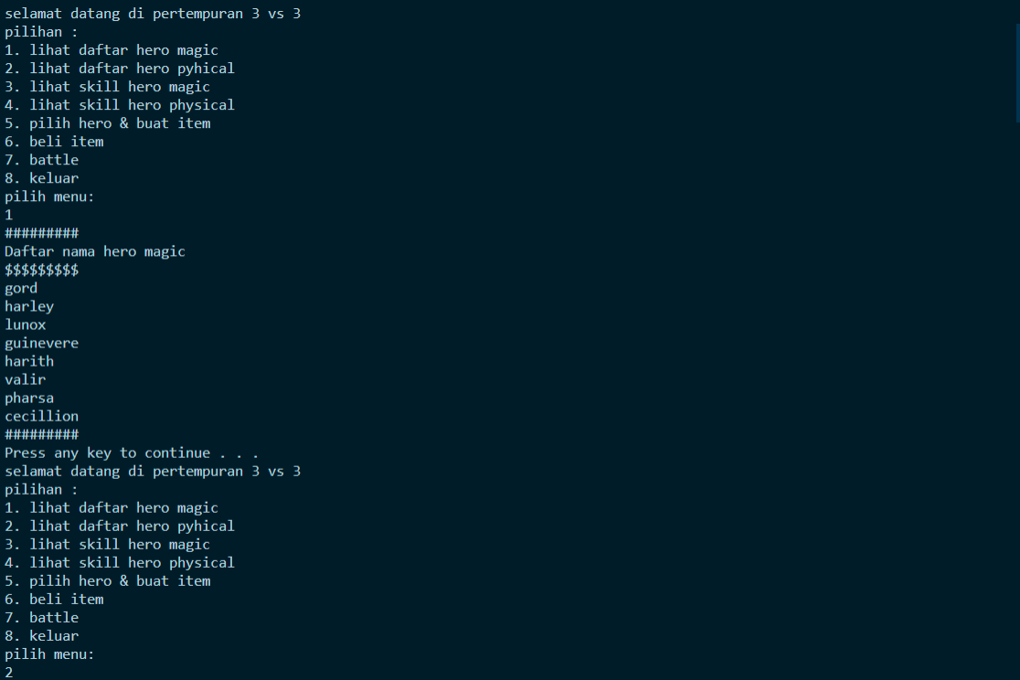

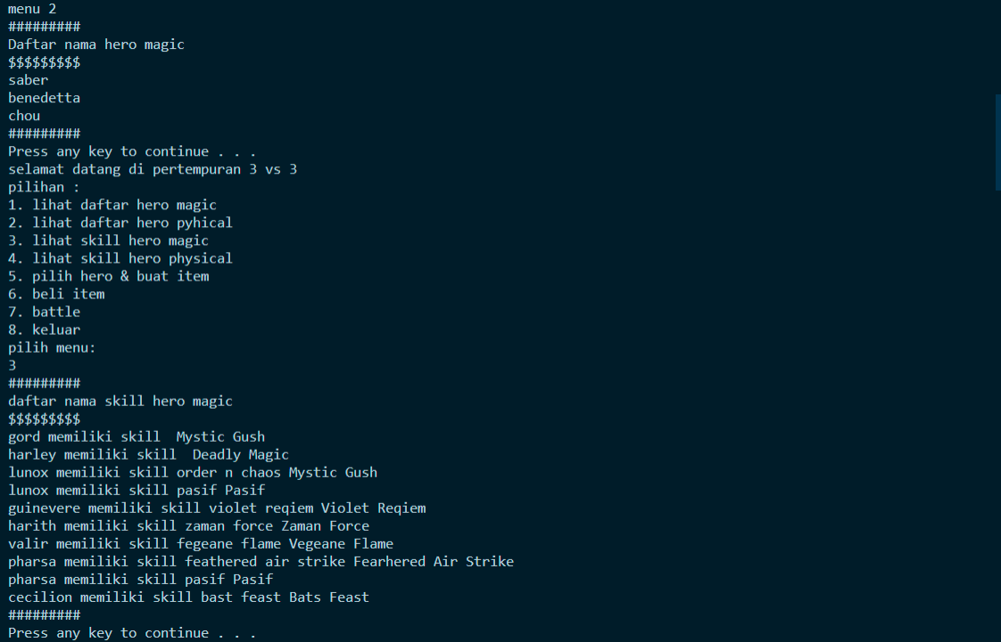

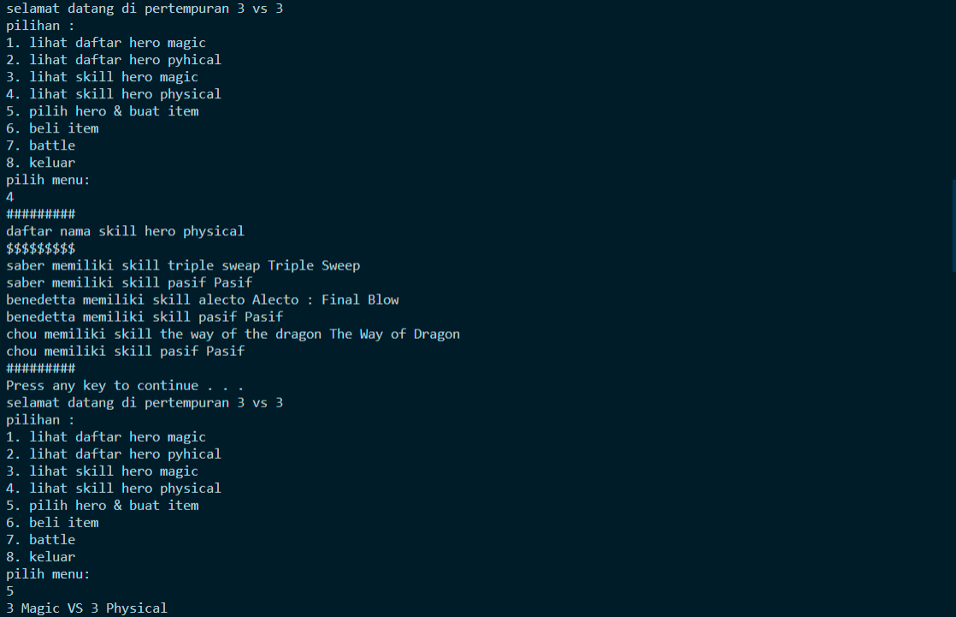

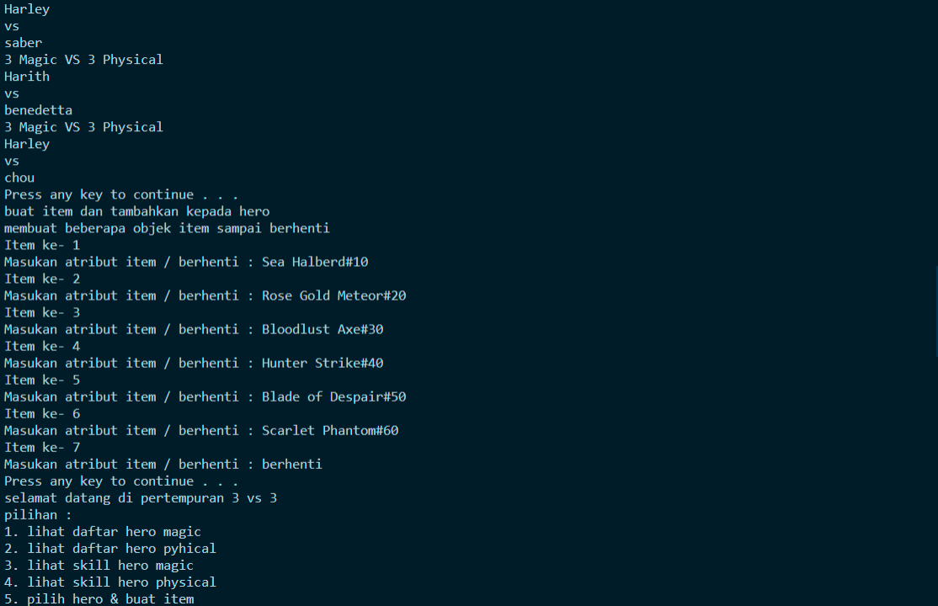

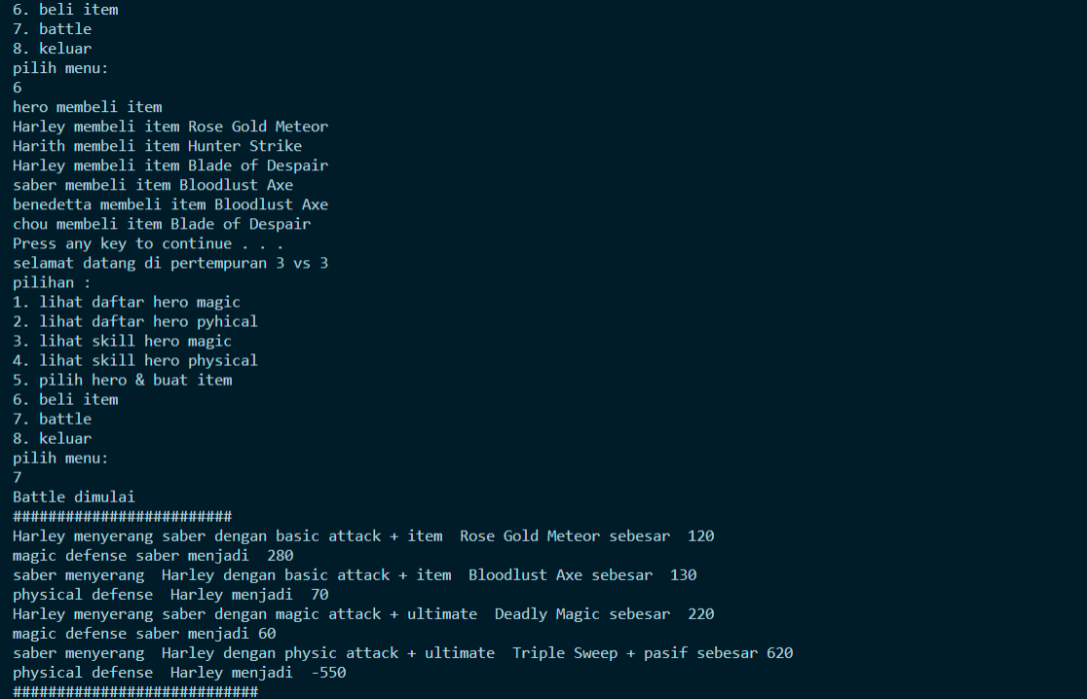

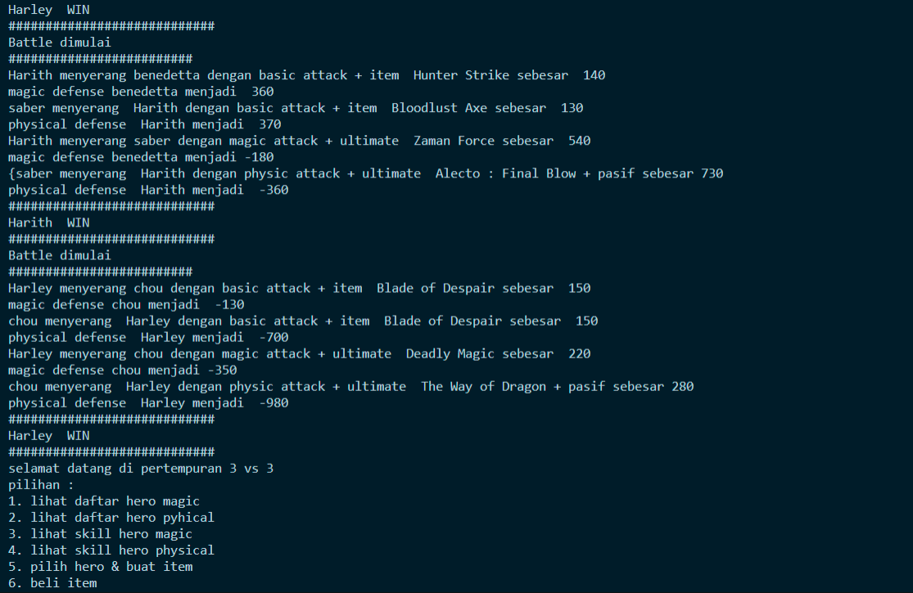



Keterangan Output Menu 7 (Battle):

# HARLEY VS SABER

|  |  |  |  |  |  |  |  |  |  |  |  |  |  |  |  |  |  |  |  |  |  |  |  |  |
| --- | --- | --- | --- | --- | --- | --- | --- | --- | --- | --- | --- | --- | --- | --- | --- | --- | --- | --- | --- | --- | --- | --- | --- | --- |
| **serang** | **Hero** | | |  | **Lawan** | | | | **BA** | **Item** | **Damage** | | | **Defense awal** | | | |  | **HP awal** | **Defense akhir** | | | | **HP akhir** |
| **1** |  | **Harley** |  |  |  | **Saber** | |  | **100** | **20** |  | **120** |  |  | **400** |  | |  | **400** |  |  | **280** | | **400** |
| **2** |  | **Saber** | |  |  | **Harley** |  | | **100** | **30** |  | **130** |  |  | **200** |  | |  | **700** |  | **70** | |  | **700** |
|  |  | | |  |  | | | |  |  |  | | |  | | | |  |  |  | | | |  |
| **serang** | **Hero** | | |  | **Lawan** | | | | **MA**  **/ PA** | **Ulti + Pasif** | **Damage** | | | **Defense awal +**  **skill** | | | |  | **HP awal** | **Defense akhir** | | | | **HP akhir** |
| **3** |  | **Harley** |  |  |  | **Saber** | |  | **200** | **20** |  | **220** |  |  | **280 + 20** | | |  | **400** |  |  | **60** | | **400** |
| **4** |  | **Saber** | |  |  | **Harley** |  | | **400** | **20 +**  **200** |  | **620** |  |  | **70 + 70** | |  |  | **700** |  | **-(550)** | | | **700** |
|  | |  |  |  | |
|  |  | | |  |  | | | |  |  |  | | |  | | | |  |  |  | | | |  |
|  | | | |  | | | | | |  | **Harley WIN** | | | | | | |  | |  | | | | |

# HARITH VS BENEDETTA

|  |  |  |  |  |  |  |  |  |  |  |  |  |  |  |  |  |  |  |  |  |  |  |  |  |  |  |  |  |  |
| --- | --- | --- | --- | --- | --- | --- | --- | --- | --- | --- | --- | --- | --- | --- | --- | --- | --- | --- | --- | --- | --- | --- | --- | --- | --- | --- | --- | --- | --- |
| **serang** | | **Hero** | | |  | **Lawan** | | | | **BA** | | **Item** | | **Damage** | | | **Defense awal** | | |  | **HP awal** | | **Defense akhir** | | | | **HP akhir** | | |
| **1** | |  | **Harith** |  |  |  | **Bened** | |  | **100** | | **40** | |  | **140** |  |  | **500** |  |  | **300** | |  | **360** |  | | **300** | | |
| **2** | |  | **Bened** | |  |  | **Harith** |  | | **100** | | **30** | |  | **130** |  |  | **500** |  |  | **400** | |  | **370** |  | | **500** | | |
|  | |  | | |  |  | | | |  | |  | |  | | |  | | |  |  | |  | | | |  | | |
| **serang** | | **Hero** | | |  | **Lawan** | | | | **MA**  **/ PA** | | **Ulti + Pasif** | | **Damage** | | | **Defense awal +**  **skill** | | |  | **HP awal** | | **Defense akhir** | | | | **HP akhir** | | |
| **3** | |  | **Harith** |  |  |  | **Bened** | |  | **500** | | **40** | |  | **550** |  |  | **370 + 15** | |  | **300** | |  | **-(180)** | |  |  | **300** |  |
|  | **4** |  | **Bened** | |  |  | **Harith** |  | |  | **500** |  | **30 + 200** |  | **730** | |  | **370 + 40** | |  |  | **500** |  | **-(360)** | | |  | **500** | |
|  | |  | | |  |  | | | |  | |  | |  | | |  | | |  |  | |  | | | |  | | |
|  | | | | |  | | | | | | |  | | **Lunox WIN** | | | | | |  | | |  | | | | | | |

# Guinevere VS CHOU

|  |  |  |  |  |  |  |  |  |  |  |  |  |  |  |  |  |  |  |  |  |  |  |  |  |  |  |  |  |  |
| --- | --- | --- | --- | --- | --- | --- | --- | --- | --- | --- | --- | --- | --- | --- | --- | --- | --- | --- | --- | --- | --- | --- | --- | --- | --- | --- | --- | --- | --- |
| **serang** | | **Hero** | | |  | **Lawan** | | |  | **BA** | | **Item** | | **Damage** | | | **Defense awal** | | | | **HP awal** | | **Defense akhir** | | | | **HP akhir** | | |
| **1** | |  | **Harley** | |  |  | **Chou** |  |  | **100** | | **50** | |  | **150** |  |  | **300** |  | | **500** | |  | **-** | **(130)** | | **500** | | |
| **2** | |  | **Chou** |  |  |  | **Harley** | |  | **100** | | **50** | |  | **150** |  |  | **700** |  | | **500** | |  | **270** |  | | **500** | | |
|  | |  | | |  |  | | |  |  | |  | |  | | |  | | | |  | |  | | | |  | | |
| **serang** | | **Hero** | | |  | **Lawan** | | |  | **MA**  **/ PA** | | **Ulti + Pasif** | | **Damage** | | | **Defense awal +**  **skill** | | | | **HP awal** | | **Defense akhir** | | | | **HP akhir** | | |
| **3** | |  | **Guin** | |  |  | **Chou** |  |  | **400** | | **40** | |  | **440** |  |  | **270 +70** | |  | **500** | | **-** | **(350)** | |  |  | **500** |  |
|  | |  |  |  | |  | |  |
|  | **4** |  | **Chou** |  |  |  | **Guin** | |  | **300** |  |  | **40 + 200** |  | **540** | |  | **-(130) + 50** | | |  | **500** |  | **-(980)** | | |  | **500** | |
|  | |  | | |  |  | | |  |  | |  | |  | | |  | | | |  | |  | | | |  | | |
|  | | | | |  | | | | **Chou WIN** | | | | | | | | | | | | | |  | | | | | | |